3rd Malikussaleh International Conference
on Multidiciplinary Studies 2022 (3rd MICoMS 2022)
INTERNATIONAL CONFERENCE PROCEEDINGS ISSN: xx/xxx
|
RESEARCH ARTICLE
Biodiesel from Used Cooking Oil Using Nipah (Nyypa Fruticans) Skin Ash as A Heterogeneous Catalyst By Transesterification Process
Zainuddin Ginting¹*, Meriatna², Rizka Mulyawan³, Tata Tirani⁴,
Asnadia⁵, Luthfi Mughni Anisa Haryono⁶
^{1,2,3,4,5,6} Chemical Engineering Department, Faculty of Engineering, Malikussaleh University, Reuleut, North Aceh, 24187, Indonesia
*Corresponding author. Email: zginting@unimal.ac.id

ABSTRACT
One of the consequences of excessive palm oil use is the production of waste palm oil (used cooking oil). To overcome this problem, efforts are needed to convert used cooking oil into more valuable products, such as biodiesel; because of its high fatty acid content, the used cooking oil has considerable potential in developing biodiesel fuel. This research aims to utilize used cooking oil in making biodiesel using heterogeneous catalyst ash derived from Nipah fruit skin calcined at 500 °C for ± 4 hours. Nipah is a type of palm (monocotyledon) that grows in mangrove forest ecosystems, in tidal areas near the seaside, or offshore. The characteristics of parts of Nipah, such as leaves, and skin, chemically contain a lot of cellulose, hemicellulose, and lignin and contain inorganic elements such as Na, K, Cl, Mg, Ca, Si, P, S, and Al. The transesterification process reacts oil with methanol to produce methyl esters and glycerol. Process variables, namely transesterification reaction time of 60, 90, 120, and 150 minutes, and the mole ratio of methanol to oil of 1:19, 1:21, and 1:23, were observed in this experiment. Biodiesel characteristics were obtained with a density of 860.2 g/mL and a viscosity of 2.37 mm2/s. They contained 44.14% Palmitic acid and 43.04% Octadecenoic acid (oleic), which is to the Indonesian National Standard (SNI). The maximum yield obtained was 93.3598% using a mole ratio of oil: methanol 1:23 at 60°C for 120 minutes, TFT 1:1, and 3% catalyst mass. The results obtained in this study indicate that Nipah fruit skin-based catalysts can be used to produce biodiesel.
Keywords: Biodiesel, Catalyst, Methyl Ester, Nipah skin ash, Transesterification
1. INTRODUCTION
Indonesia's industrial development will increase fuel consumption and domestic oil production. The demand for fuel oil will increase Indonesia's dependence on imported materials. From 2011-2030, domestic oil demand is expected to double from 327 million barrels to 578 million barrels by 2030, but this is not the case with oil production. During the same period, oil production decreased from 329 million barrels to 124 million barrels (Sugiono et al., 2013).
An alternative liquid fuel that can be used as a substitute for petroleum is vegetable oil because it is abundant and renewable. Vegetable oil that is widely used in Indonesia comes from palm oil which is rich in palmitic acid (saturated fatty acid) and oleic acid (unsaturated fatty acid). Biodiesel can be produced from vegetable oils, animal fats, waste oils, and so on (Singh et al., 2019).
According to the American Society for Testing Materials (ASTM International), biodiesel is defined as long-chain mono-alkyl esters of fatty acids derived from renewable sources used in diesel engines. Biodiesel is a renewable, biodegradable, non-toxic, and environmentally friendly fuel. Used cooking oil is one of the raw materials that can be used to produce biodiesel because it still contains free fatty acids (Darmawan & Susila, 2013) [1].
Biodiesel is made from vegetable oil by converting triglycerides into fatty acid methyl esters. The transesterification reaction is the reaction of triglycerides and methanol to form methyl esters and glycerol. Two types of catalysts can be used to produce biodiesel: homogeneous and heterogeneous catalysts. The use of homogeneous catalysts has several disadvantages, namely that it takes a long time to separate from the mixture and cannot be reused (Nasikin and Susanto, 2010). One way to reduce the pollution of biodiesel products and improve the efficiency of the manufacturing process is to use heterogeneous solid catalysts in the transesterification process [2].
Because homogeneous base catalysts are relatively expensive in the market, it is tried to use catalysts from natural materials. Various studies have used heterogeneous catalysts in biodiesel production, such as banana stem ash, palm empty fruit bunch ash, and eggshell ash, as heterogeneous catalysts in biodiesel production. In this research, the author would like to improve by using Nipah husk ash as a catalyst in the production of biodiesel made from used cooking oil. Nipah fruit leather chemically contains inorganic elements such as Na, K, Cl, Mg, Ca, Si, P, S, and Al so that it can be applied as a heterogen base catalyst in biodiesel [3].
The Nipah plant thrives in tidal forests (mangrove forests) and swamps or brackish river estuaries. In Indonesia, the Nipah plant area is 10% of the tidal area of 7 million hectares or around 700,000 hectares. Its distribution covers the islands of Sumatra, Kalimantan, Java, Sulawesi, Maluku, and Irian Jaya (Rachman and Sudarto, 1992).
If observed more deeply, Nipah plant waste, especially frond fibre and Nipah fruit skin fibre, can be further utilised as raw material for paper or pulp. According to Akpakpan, et.al. (2011), that Nipah fronds can be used as pulp raw material because they contain 42.22% cellulose and 19.85% lignin. Meanwhile, according to Tamunaidu and Shiro (2010), nipah fruit peel fibre, which can be called husk, contains 36.5% cellulose and 27.3% lignin [4].
Nipah has been widely used in research such as previous studies that have been conducted by Ari et al (2013), namely the Utilisation of Nipah fruit skin for making biocharcoal briquettes as an alternative energy source, Putri et al (2020), namely the characteristics of anthocyanins from Nipah fruit skin (Nypa fruticans) as Natural Dyes with the soxhletiation method, Susinggih et al (2013), namely the study of pulping processes of frond fibres and nipah fruit skin fibres (Nypa Fruticans) with chemical methods (study of NaOH solution concentration) [5].
The use of co-solvent is an appropriate alternative to overcome the problem of solubility. A single-phase reaction can be formed by adding a solvent that can increase the solubility of the oil, the solvent hereinafter referred to as a co-solvent (Mahajan et al., 2006). The co-solvent is highly soluble in alcohol, fatty acids and triglycerides. The selected co-solvent has a boiling point close to methanol which can facilitate the separation process at the end of the reaction. Several cosolvents have been used for the transesterification reaction, including n-hexane, diethyl ether, acetone, 2-propanol, tetrahydrofuran, or ethyl acetate. This study aimed to investigate the effect of used cooking oil, methanol feed ratio on biodiesel yield, and the addition of co-solvent on biodiesel yield using heterogeneous catalysts from Nipah fruit skin, as well as determine the methyl ester content contained in biodiesel by GC-MS analysis and the characteristics of the catalyst using XRD, and SEM [6].
2. MATERIALS AND METHODS
1.1. Materials
Nipah skin samples were taken from Gereugok, Bireuen, Aceh, while used cooking oil was taken from fried chicken sellers around the city of Lhokseumawe, Aceh. Chemicals and reagents for methyl ester synthesis including Methanol, KOH, Phenolphthalein, and Tertrahydrofuran (TFT) were purchased from Merck. Distilled water was used to make reagents.
1.2. Preparation of CPO and Nipah Fruit Skin
Preparation of raw materials was carried out by screening used cooking oil using filter paper and Performing FFA analysis on used cooking oil. The used cooking oil used as raw material in the study had an initial %FFA of 4.6 wt%; thus, pretreatment was necessary to reduce its fatty acid content. The method chosen is the esterification reaction with the reaction conditions: the amount of 0.5 wt% H₂SO₄ catalyst against oil, a reaction time of 2 hours, 60°C and atmospheric pressure. After the esterification reaction, the fatty acid content in the oil will decrease. The Nipah fruit skin was cleaned and then dried in an oven at a temperature of 110°C ± 4 hours, then placed into a furnace at a temperature of ± 500°C for ± 2 hours, then placed into a desiccator. After drying, the Nipah skin was used as a catalyst.
1.3. Synthesis of Methyl Ester
The biodiesel production process consists of preparing Nipah skin ash, preparing used cooking oil, transesterification reaction, and purification. The variables in this research are a variation of the mole ratio of methanol and oil 1:19; 1:21; 1:23, and reaction times 60, 90, 120, and 150 minutes. The analyses conducted were yield (%), density (Kg/cm3), viscosity (mm²/s), biodiesel compound composition analysis (GC-MS), and morphology and composition test of Nipah skin ash catalyst (SEM-EDX).
In the catalyst preparation process, Nipah skin was put into a furnace with a temperature of 500 ºC for 4 hours. Furthermore, the preparation was carried out to determine the initial ALB content in used cooking oil before continuing the transesterification reaction process.
The transesterification process was carried out in a batch reactor by mixing 50 grams of used cooking oil and methanol following the variation of oil to methanol ratio determined using Nipah skin ash catalyst 3% of the oil weight. The oil was heated to a temperature of 60 °C and stirred using a magnetic stirrer. Then Methanol and Nipah fruit skin ash catalyst were added and stirred until homogeneous with a temperature of 60 °C with a predetermined time variation. After the temperature and reaction time were reached, filter the solution mixture from the heterogeneous catalyst. Then, separate the mixture into a separating funnel and let it stand for 24 hours. Two layers will be formed, the top layer is methyl ester, and the bottom layer is glycerol. The methyl ester was distilled at 60 °C to remove methanol. The purified methyl ester is stored in a sample bottle.
3. RESULT AND DISCUSSION
3.1. Effect of Mole Ratio and Reaction Time on Yield (%)
The effect of the methanol mole ratio and reaction time on the yield of biodiesel produced can be seen in Figure 1.
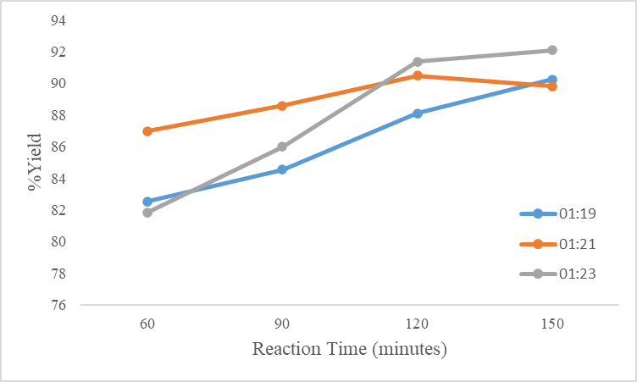
Figure 1 Graph of Effect of Mole Ratio and Reaction Time on Yield (%)
Based on theory, the longer the reaction time, the greater the contact between substances so that it will produce a large conversion [7]. In the research that has been done, the data obtained that during the time of 60 minutes to 150 minutes with a mole ratio of 1:19, 1:21, and 1:23, the yield conversion results continue to increase. This proves that the longer the reaction time, the yield produced will continue to increase. Figure 1 shows that at a mole ratio of 1:21 with a reaction time of 150 minutes, the yield produced increased to 39.8094%, while at a mole ratio of 1:23 with the same reaction time, the yield decreased to 22.0714%.
At the ratio of 1:21, the reaction has reached the equilibrium point. In the ratio of 1:23, the yield obtained decreased because the higher the ratio of alcohol used, the higher the glycerol level produced. According to Yunnowati et al. (2008), high glycerol in the methyl ester solution will encourage the reaction to turn left to form monoglycerides so that the biodiesel yield will decrease [8].

3.2. Effect of Mole Ratio and Reaction Time on Density
The effect of the mole ratio and reaction time on density can be seen in Figure 2.
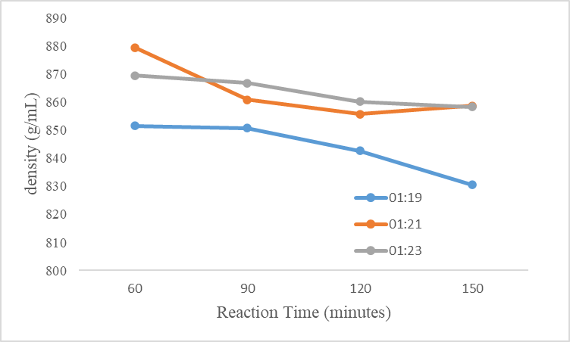
Figure 2 Graph of Effect of Mole Ratio and Reaction Time on Density (g/mL)
The amount of methanol does not affect the density produced, but the amount states that the density of biodiesel produced meets the SNI or does not meet the SNI. The density results obtained at a methanol mole ratio of 1:19, 1:21, and 1:23 at transesterification reaction times of 60, 90, 120, and 150 can be seen in Figure 2.
Based on the density test results, it can be seen that the reaction time affects the density of biodiesel, namely the density value increases and decreases. This can be caused by the lack of perfection in the distillation process so that there is still methanol content or impurities in the sample. According to Affandi et al. (2013), a poor purification stage can affect and cause the density of biodiesel to vary [9].
According to the Indonesian National Standard (SNI), the density of biodiesel is between the range of 850 - 890 Kg/m3, but from the results obtained, not all biodiesel produced is by the SNI. According to Hadrah et al., 2018), the density value of biodiesel that is by the quality standard (SNI) then its use can produce perfect combustion, while biodiesel with a density that does not meet the SNI standard will cause incomplete combustion reactions that can increase emissions and engine wear [10][11].
3.3. Effect of Mole Ratio and Reaction Time on Viscosity
The effect of the mole ratio and reaction time on viscosity can be seen in Figure 3.
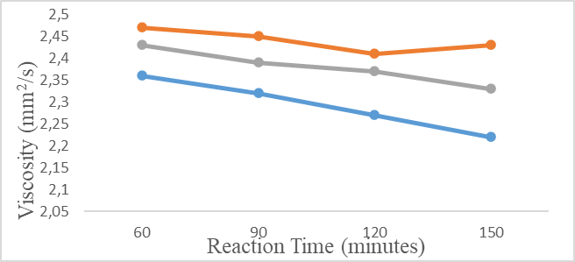
Figure 3 Graph of the Effect of Mole Ratio and Reaction Time on Viscosity
The viscosity results obtained at a methanol mole ratio of 1:19, 1:21, and 1:23 at transesterification reaction times of 60, 90, 120, and 150 can be seen in Figure 3.3. Viscosity has an inversely correlative relationship with the length of reaction time. The longer the reaction time, the lower the viscosity of the biodiesel. Saputra et al. (2012) have conducted biodiesel research using snail shells, and the longer the reaction time, the viscosity of biodiesel also decreases. Viscosity is closely related to density; the higher the density, the higher the viscosity value [12].
The expected viscosity is the viscosity by the Indonesian National Standard (SNI). The results of the study found that the viscosity value was not constant and tended to fluctuate. The expected viscosity is viscosity by SNI standards. If the fuel is too thick, it can make it difficult to flow, pump, and ignite. If the fuel is too thin, it is difficult to spread the fuel, making it difficult to burn and will cause leaks in the injection pipe [13][14].
3.4. Composition Analysis of Hydrocarbon Compounds in Biodiesel
Qualitative and quantitative analysis is a qualitative and quantitative analysis that can be used to determine the type of fatty acid content in biodiesel and its quantity. Methyl ester biodiesel analyzed by GC-MS showed four dominant peaks, as shown in Figure 4.
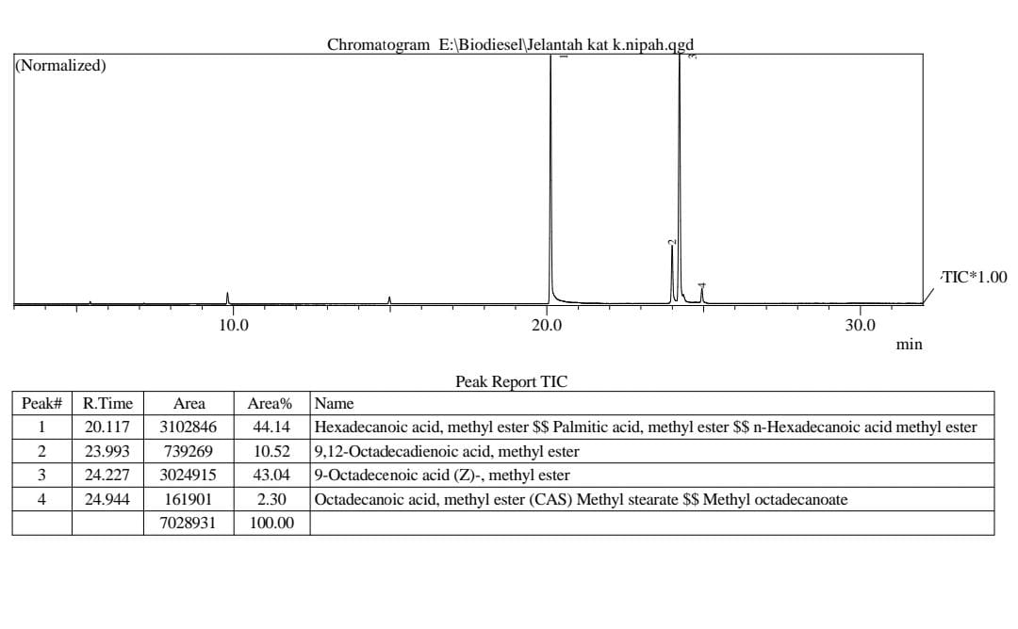
Figure 4 Results of GC-MS Analysis
Based on the results of GC analysis, the main fatty acid component in the used cooking oil sample is at peak 1, namely palmitic acid at 44.14%. At peak 2, namely saturated fatty acid octadecadienoic acid (linoleic acid) at 10.52%, at peak 3, unsaturated fatty acid in the form of octadecenoic acid (oleic) at 43.04%, and the last peak of the results of the analysis with GCMS, namely saturated fatty acid in the form of stearic acid at 2.30% which is the minor fatty acid. Based on the results of the GC-MS test analysis, it can be stated that the data are actual biodiesel compounds, namely methyl esters. This shows that used cooking oil can produce biodiesel from methyl esters [15].
3.5. SEM Analysis of Morphology and Elemental Composition of Catalysts
SEM-EDS analysis displays the components in an elemental form, as shown in Figure 5.
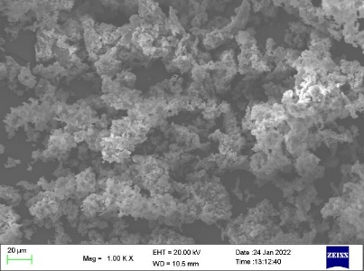 | 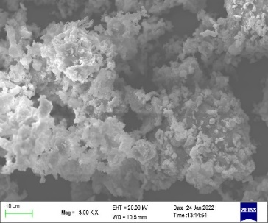
(a) | (b)
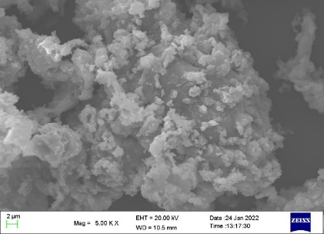 | 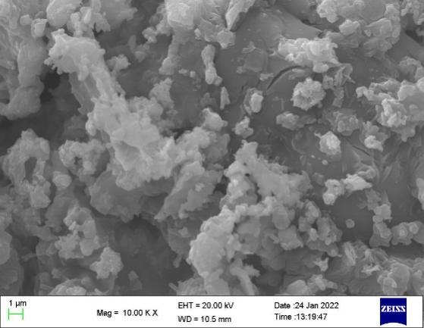
(c) | (d)
Figure 5 Photographs of SEM Test Results of Nipah Skin Ash with Magnification (a) 1000x (b) 3000x (c) 5000x (d) 10,000x
The purpose of SEM analysis of Nipah skin ash is to determine the morphological structure of Nipah skin ash. The picture above shows the morphological structure of Nipah skin ash from the SEM analysis. Figure (a) clearly shows the structure of Nipah skin ash, with a magnification of 1000x and a particle size of 20µm. Figure (b) shows the result of SEM analysis of Nipah skin ash with 3000x magnification with a particle size of 5µm. Figure (c) shows the effect of Nipah husk ash with an embellishment of 5000x, with a particle size of 2µm. Figure (d) shows the result of Nipah skin ash with 10000x magnification, Nipah skin ash with a particle size of 1µm with a slightly concave surface that blends. The catalysts from the experiment tended to be irregularly round in structure.
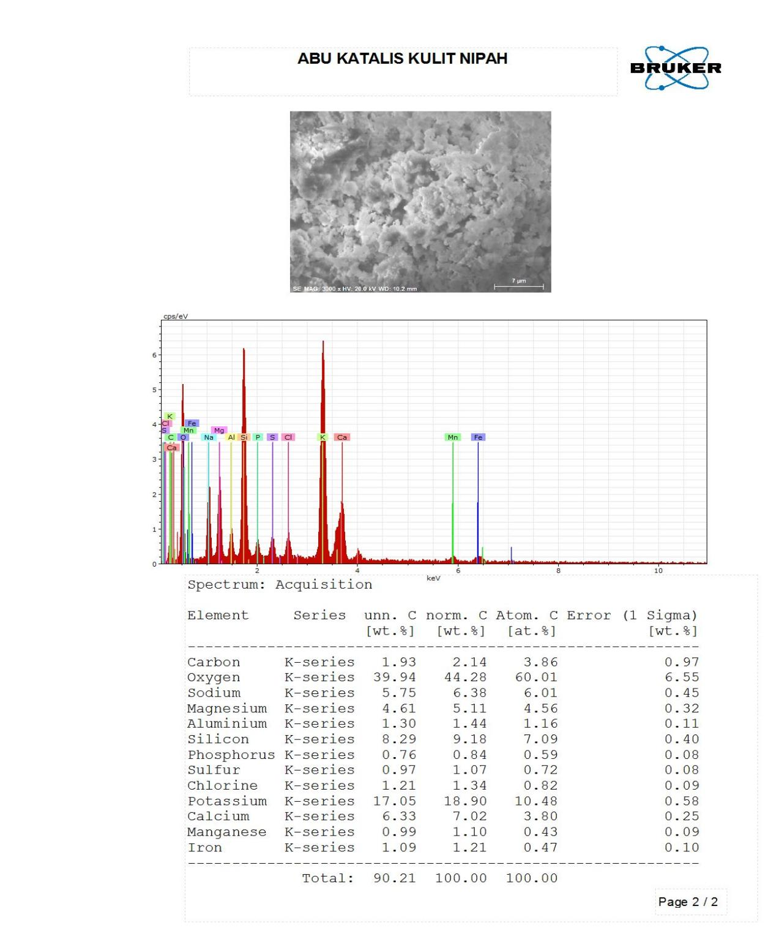
Figure 6 Substance composition photograph of Nipah skin ash SEM test results
The results of Figure 6 show that there are twelve prominent components in this catalyst sample. These components are the components found in Nipah skin ash. This identifies the presence of potassium content, so Nipah skin ash can be used as a catalyst in the transesterification process to make biodiesel from used cooking oil, also evidenced by the formation of methyl ester from used cooking oil [16].
4. CONCLUSIONS
Nipah skin waste can be used as a heterogeneous catalyst in making biodiesel from used cooking oil with the highest yield of 93.3598% at a mole ratio of 1:21 with a transesterification reaction time of 150 minutes. The GC-MS test proved that the yield obtained was methyl ester. The primary fatty acids contained in the used cooking oil raw material were palmitic acid at 44.14% and Octadecenoic acid (oleic) at 43.04%. The characteristics of the biodiesel produced were obtained density and viscosity of 858.7 Kg/m³.
AUTHORS’ CONTRIBUTIONS
All authors contributed to the study conception and design. Material preparation, data collection and analysis were
performed by Zainuddin Ginting, Meriatna, and Rizka Mulyawan. Products characteristics was analyzed by
Meriatna, and Rizka Mulyawan. The first draft of the manuscript was written by Zainuddin Ginting, Tata Tirani,
Asnadia, Luthfi, and Mughni Anisa Haryono. All authors read and approved the final manuscript.
ACKNOWLEDGMENTS
The authors would like to thank many parties for the implementation of this research. The authors gratefully acknowledge that this research was funded by the Advanced Knowledge and Skills for Sustainable Growth Project in Indonesia - Asian Development Bank (AKSI-ADB) in the Malikussaleh University Budget Implementation List for Fiscal Year 2022, which is funded through contract number 25/UN45.3.8/HK.02.03/2022.
REFERENCES
[1] Affandy, R. D. N., et al., Biodiesel Production from Beef Fat by Transesterification Process with NaOH Base Catalyst, USU Journal of Chemical Engineering, Vol. 2, No.1, 2013, pp. 173-181, DOI: https://doi.org/10.1007/4-540-11394-7_26
[2] Hadrah, H., Kasman, M., and Sari, F. M., Analysis of Used Cooking Oil as Biodiesel Fuel with Transesterification Process, Journal of Environmental Design, Vol. 1, No. 1, 2018, pp. 16-22, https://doi.org/10.33087/daurling.v1i1.4.
[3] Jalaluddin Jalaluddin, Zainuddin Ginting, and Syariful Maliki, Biodiesel Production from Crude Palm Oil Using Kapok Skin KOH (Ceiba Pentandra) Catalyst as Solid Green Catalyst, Jurnal of Ecological Engineering, 2022, 23(5):286–292. DOI: https://doi.org/10.12911/22998993/147404
[4] I Ibrahim, AM Syam, M Muhammad, and Z Ginting, Biodiesel Production from a Mixture of Rubber Seed Oil and Waste Oil Through the Alcoholysis Process with Catalysts Based on Vegetable Waste, International Journal of Engineering, Science and Information Technology, Vol.1, No.4, 2021, DOI: https://doi.org/10.52088/ijesty.v1i4.182
[5] Fan X., Burton R., Austic G, Preparation and Characterization of Biodiesel Produced from Recycled Canola Oil, The Open Fuels and Energy Science Journal 2, 2009, pp. 113–118. DOI: https://doi.org/10.1007/s10553-010-0225-4
[6] Jitputti J., Kitiyanan B., Rangsunvigit P., Bunyakiat K., Attanatho L., Jenvanitpanjakul P, Transesterification Of Crude Palm Kernel Oil And Crude Coconut Oil By Different Solid Catalysts, Chemical Engineering Journal 116, 2016, pp. 61–66, DOI: https://doi.org/10.1016/j.cej.2005.09.025
[7] Meher L.C., Dharmagadda V.S.S., Naik S.N., Optimization Of Alkali-Catalyzed Transesterification Of Pongamia Pinnata Oil For Production Of Biodiesel, Bioresource Technology, 97, 2016, pp. 1392–1397. DOI: https://doi.org/https://doi.org/10.1016/j.biortech.2005.07.003
[8] Jumina, Yasodhara Y., Triono S., Kurniawan Y.S., Priastomo Y., Chawla H.M., Kumar N, Preparation and evaluation of alpha-cellulose sulfate based new heterogeneous catalyst for production of biodiesel, Journal of Applied Polymer Science 138, 2021, pp. 49658. DOI: https://doi.org/https://doi.org/10.1002/app.49658
[9] Tuty Emilia Agustina, Eddy Heraldy, Fitri Hadiah, Biodiesel Production of Palm Oil Mill Effluent by Using Hydrotalcite Catalyst, J. Ecol. Eng. 2022; 23(6):172–181, DOI: https://doi.org/10.12911/22998993/148153
[10] Pathak M., Kalita N., Baruah D., Bhowmik R, Production of Biodiesel from Waste Cooking Oil, 5th International Conference on Science Technology Engineering and Mathematics, ICONSTEM 2019, 5(May), pp. 270–274. DOI: https://doi.org/10.1109/ICONSTEM.2019.8918857
[11] Putra I.M.W., Production of Biodiesel from Waste Cooking Oil by Transesterification Process using Heterogeneous Catalyst. Nigerian Journal of Environmental Sciences and Technology, 5(2), 2021, pp. 501–510. https://doi.org/10.36263/nijest.2021.02.0308
[12] Liu Y., Tu Q., Knothe G., Lu M., Direct Transesterification Of Spent Coffee Grounds For Biodiesel Production. Fuel, 199, 2017, pp. 157–161, DOI: https://doi. org/10.1016/j.fuel.2017.02.094
[13] Mantovani S.A., The Effect of Catalyst Mass and Reaction Time on the Conversion of Biodiesel from Used Cooking Oil with CaO Catalyst from Eggshells. Industrial Engineering Scientific Journal, 19(2), 2020, pp. 212–222. DOI: https://doi.org/10.13621/22997381/147923
[14] Dalimunthe I.S., Restuhadi F., Efendi R., Synthesis of Biodiesel from Used Cooking Oil using Heterogenous Catalyst Based on Chicken Egg shells, Agricultural Science Journal, 3(2), 2016, pp. 1–6, DOI: https://doi.org/10.1016/j.asj.2016.07.135
[15] Prihanto A. and Irawan T.A.B., The Effect of Temperature, Catalyst Concentration, and Methanol-Oil Ratio on Biodiesel Yield from Used Cooking Oil through Neutralization-Transesterification Process. Methane Journal, 13(1), 2017, pp. 30–36, DOI: https://doi.org/10.1007/4-540-11394-7_26
[16] Wahyuni S., Ramli, Mahrizal, The Effect of Process Temperature and Deposition Time on the Quality of Biodiesel from Used Cooking Oil, Pillar of Physics, 6(10), 2015, pp. 33–40. DOI: https://doi.org/10.16582/11523653/163553

