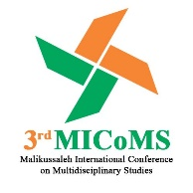

3rd Malikussaleh International Conference
on Multidiciplinary Studies 2022 (3rd MICoMS 2022)
INTERNATIONAL CONFERENCE PROCEEDINGS ISSN: xx/xxx
|
RESEARCH ARTICLE
Development of Android-based Chemistry Learning Media Integrated AIR Model
Sri Setiawaty^{1*}, Isna Rezkia Lukman², Riska Imanda³, Reza Putra⁴
^{1,2,3} Department of Chemistry Education, Malikussaleh University, Lhokseumawe, Aceh, Indonesia
⁴ Department of Mechanical Engineering, Malikussaleh University, Lhokseumawe, Aceh, Indonesia
*Corresponding author. Email: sri.setiawaty@unimal.ac.id

ABSTRACT
This study aims to determine the feasibility of chemistry learning media based Android integrated with the AIR (Auditory, Intellectually, Repetition) model that was developed to increase students' cognitive learning outcomes, as well as to determine student readiness with the renewal of learning modes and student responses to the developed learning media. This study uses the type of Research and Development (R&D) research with adapted from Borg & Gall (2007) dan 4-D (Thiagarajan, dkk., 1974) procedural. The learning media product being developed in the form of an android application with a AIR model on chemistry atomic structure concepts. The android application used in this research is the Smart App Creator software. The validity of the media and the quality of the learning media developed obtained the results of an assessment are 85% and 86% (Very Good), then received a positive response from chemistry is 91%, Furthermore the media was developed should be improve cognitive aspect and significantly with a comparison of the average value of the pretest score of 33.00 and posttest of 81.08 to learning outcomes.
Keywords: Android, Chemistry learning media, AIR model, R&D.
1. INTRODUCTION
Education must be in line with the quality of educators as well as adequate facilities and infrastructure in order to realize education and create a quality and quality generation, in accordance with the paradigm shift in the direction of education towards technology. Based on Ministerial Regulation (“Permendikbud 109 /2013”) concerning the Implementation of Distance Education (Pendidikan Jarak Jauh/PJJ) in Higher Education, and “Permendikbud 119/2014” concerning Implementation of PJJ for Elementary and Secondary Education, PJJ aims to increase the expansion and equitable distribution of access and facilitate services ranging from basic education to secondary education, with open characteristics, independent learning, complete learning, using educational information and communication technology, and using other educational technologies.
In this regards, all areas of life will lead to digitalization, especially with the current Covid-19 pandemic situation. This has hampered the face-to-face (conventional) learning process, and physical and social distancing programs must be carried out. so that the digitalization of education cannot be ignored anymore. In accordance with government recommendations through the Ministry of Education and Culture in Circular Letter (“SE 2/2020”) concerning Prevention and Handling of Covid-19 within the Ministry of Education and Culture and Circular Letter (“SE 3/2020”) concerning Prevention of Covid-19 in Education Units. Furthermore, the Ministry of Education and Culture's policy of “Merdeka Belajar” and “Kampus Merdeka” inspired researchers to support the program through innovation of the PJJ mechanism in accordance with these policies, which is applied in the form of android and can be accessed by gadgets, be it PC, laptop, or mobile phone, as the current development of education has entered the realm of Education 4.0 fit for Industry 4.0.
Auditory, Intellectually, Repetition (AIR) is a effective model in the development of the students' skills in answering questions. AIR learning model assumes that learning will be effective if it pays attention to three things, namely Auditory, Intellectually and Repetition. Auditory which means learning must be through listening, speaking, achievement, argumentation, expressing opinions and responding. While intellectually means that learning must use the ability to think (mind-on), it must be by concentrating the mind and practicing using it through reasoning, investigating, identifying, discovering, creating, constructing, solving problems and applying. Then, repetition means repetition which means deepening, expanding, stabilizing by means of students being trained through giving assignments or quizzes (Fauji and Winarti, 2015).
The integration of AIR learning model is expected to solve various challenges, namely overcoming the limitations of experiments in science learning, as well as increasing cognitive aspect, where students can learn independently to solve problems and improve their logical thinking by utilizing various innovations that were born in the era of the industrial revolution. 4.0 such as internet on things, artificial intelligence, big data, and robots to improve the quality of human life (Sugiyarto, et al, 2018; Setiawaty, et al, 2020). Android-based AIR model can also be interpreted as a human- and technology-centered learning concept.
2. METHOD
The research and development procedure carried out is an adaptation of the Borg & Gall (2007) and 4-D (Define, Design, Development, and Disseminate) procedures (Thiagarajan, et al., 1974), and will be implemented in senior high schools in North Aceh Regency (SMA N 1 Muara Batu, MAN 3 Aceh Utara and MAS Syamsuddhuha). The data analysis technique used is to determine the assessment of media quality and improvement of logical thinking skills and learning outcomes. The data obtained in the form of qualitative data is converted into quantitative with criteria for the category of ideal assessment scores.
3. RESULTS AND DISCUSSION
The development of the integration of android-based AIR learning model refers to the cognitive learning outcomes demands in the Merdeka Curriculum, with the following results.
3.1. Defining Stage
At this stage an initial analysis is carried out to see the needs of students and adjust to the needs of students and school conditions (front analysis). Furthermore, a learner analysis, task analysis, concept analysis and specifying instructional objectives was also carried out design android-based chemistry learning media integrated AIR model to match competencies and learning outcomes based on the Decree of the Minister of Education and Culture of the Republic of Indonesia (“958/P/2020”) concerning Learning Outcomes in Early Childhood Education, Basic Education, and Secondary Education.
3.2. Designing Stage
Design is carried out for design before development by planning the outline before developing the product, through constructing criterion–referenced test, Media selection, Format selection, and initial design.
3.3. Development Stage
This stage consists of expert appraisal and developmental testing by focusing on validating, reviewing and assessing the feasibility of designing android AIR learning media products, The following is the percentage of assessment results obtained from material expert validators and media experts.

Figure 1 Percentage of material expert assessment validation results chart

Figure 2 Percentage of media expert assessment validation results chart
3.4. Dissemination Stage
This stage includes validation testing, packaging, diffusion and adoption. The product that has been revised at the development stage is then implemented for students to be asked for their responses and a feasibility test by teachers who teach chemistry or science.

Figure 3 The graph of the results of the media quality test by the teacher
In addition to assessing, the teachers also provided input on the developed android learning media products, namely the need for additional media content because the chemistry concepts in X class of the curriculum (Kurikulum Merdeka) was very limited. Furthermore, the results of student responses can be presented as follows.
Figure 4 The graph of the students responses
The media is also designed using smart app creator software by paying attention to the content and learning outcomes as well as the results of reviews and input from teachers and validators.
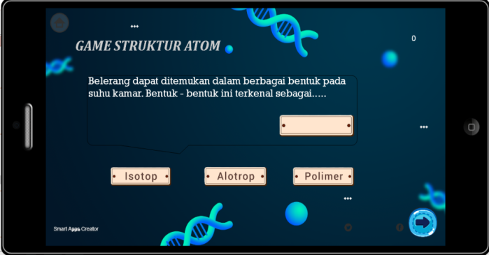
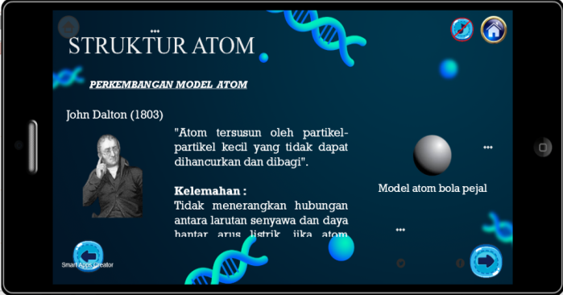
Figure 5 Display the contents of android learning media integrated AIR model
Furthermore, the application of the developed media is also able to have a significant influence on students' cognitive learning outcomes with 81% completeness.
4. CONCLUSION
Based on the results of the study, it can be concluded that the Android-based learning media integrated AIR model which was developed using the 4-D development model, has the quality of the media in terms of expert validation and the responses of teachers and students who are included in the qualifications are very suitable to be used as learning media in measuring student cognitive learning outcomes. Furthermore, it is hoped that there will be improvements to the learning media that have been made by researchers by optimizing the use of media widely.
ACKNOWLEDGMENTS
This paper and the research behind it would not have been possible without the exceptional support of our teams, Chemistry Education, and Mechanical Engineering, Malikussaleh University. We are also grateful to Dr. Syahrial for insightful discussions. This research was supported by Lembaga Penelitian dan Pengabdian Kepada Masyarakat (LPPM) AKSI-ADB Malikussaleh University. The generosity and expertise of one and all have improved this study in innumerable ways and saved me from many errors; thank you so much.
REFERENCES
[1] Gall, M., Gall, J., Borg, R. Educational Research: An introduction (8th ed.). New York, NY: Pearson Education, 2007.

[2] F, Ahmad, A, Winarti. Meningkatkan Keterampilan Berpikir Kritis dan Hasil Belajar Siswa Melalui Model Pembelajaran Auditory, Intellectually, Repetition (AIR) Pada Materi Hidrolisi Garam di Kelas XI IPA 2 SMA PGRI 6 Banjarmasin. Quantum: Jurnal Inovasi Pendidikan Sains 6 (2) (2015) pp. 1–10. DOI: http://dx.doi.org/10.20527/quantum.v6i2.1154.

[4] Sugiyarto, K. H., J. Ikhsan, I. R. Lukman. The Use of an Android–based-game in The Team Assisted Individualization to Improve Students’ Creativity and Cognitive Achievement in Chemistry, ICoSMEE, Journal of Physics: Conf. Series, (2018). DOI:10.1088/1742-6596/1022/1/012037.

[5] S, Setiawaty, N, Fatmi, A, Rahmi, R, Unaida, I, Hadiya, I, Muhammad, Alchalil, R, P, Sari. Science, Technology, Engineering, and Mathematics (STEM) Learning on Student’s Science Process Skills and Science Attitudes. Proceedings of MICoMS 2017. Emerald Publishing Limited, 1 (1) (2018) pp. 575-581. https://doi.org/10.1108/978-1-78756-793-1-00036.

