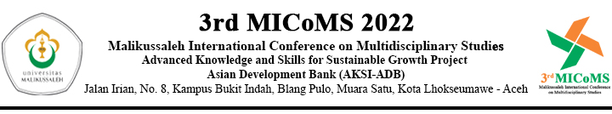
RUNDOWN
THE 3rd International Conference on Multidisciplinary Studies (MICoMS) 2022
Universitas Malikussaleh, Aceh-Indonesia
30 November 2022 – 01 Desember 2022

Day/Date | Time  WIB*) | Activities | Officials
DAY 1  Wednesday,  30 November 2022 | 09.00-09.30 | Registration | Committe
 | OPENING CEREMONY
 | 09.30-09.40 | Opening by MC | Sisca Olivia, S.T., M.S & T.Azhari, S.Pd., M.Ed
 | 09.40-09.15 | National Anthem of “Indonesia Raya” | All Participants
 | 09.15-09.25 | Opening Prayer | Rizki Yunanda, S.Sos., M.Si
 | 09.25-09.35 | Welcoming Remarks by Organizing Committte | Deassy Siska, S.Si., M.Si
 | 09.35-09.50 | Welcoming Remaks by Project Manager AKSI-ADB Universitas Malikussaleh | Dr.Ing. Sofyan, S.T, M.T
 | 09.50-10.00 | Opening Speech by Rector of Universitas Malikussaleh | Prof. Dr. Ir. Herman Fithra, S.T., M.T., IPM, ASEAN Eng
 | KEYNOTE SPEECH
 | 10.00-10.30 | Keynote 1 :  Prof. Dr. Ir. Herman Fithra, S.T., M.T., IPM, ASEAN Eng  Rektor Univeritas Malikussaleh | Moderator :  Dr. Ing. Sofyan, S.T., M.T
 | 10.30-11.00 | Keynote 2 :  Dr. Ir. Azhari, M.Sc., IPM, ASEAN Eng  Biodiesel CoE Univeritas Malikussaleh | Moderator :  Rizka Mulyawan, B.S., M.Adv.Eng
 | 11.00-11.30 | Keynote 3 :  Arie Rahmadi, Ph.D  National Research and Innovation Agency | Moderator :  Rahmawati Rusydi, S.Pi., M.Sc
 | 11.30-12.00 | Keynote 4 :  Prof. Dr. Rizalman Bin Mamat  Universiti Malaysia Pahang (Malaysia) | Moderator :  Dr. Ratri Candrasari
 | 12.00-13.00 | Discussion Session
 | 13.00-13.30 | Keynote 5 :  Dr. Souvik Ganguli  Thapar Insitute of Engineering and Technology (India) | Moderator :  T. Azhari, S.Pd., M.Ed
 | 13.30-14.00 | Keynote 6 :  Dr.Eng, Neyara Radwan  Associate Professor Mechanical Dept.Faculty of Engineering Suez Canal University Egypt & King Abdulaziz University (Arab Saudi) | Moderator :  Dr. Khalsiah, M.Hum
 | 14.00-16.00 | Parallel Session | Presenters
DAY 2  Thursday,  01 Desember 2022 | Parallel Session |  | Presenters

